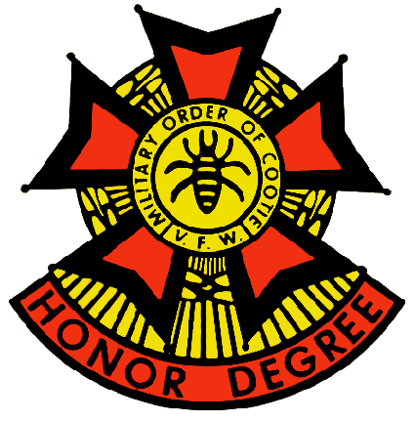
Grand of Texas

Military Order of the Cootie

Honor Degree of the Veterans of Foreign Wars

of the United States

2024-2025 Series General Orders No. 2 Jul 2024

- Shavetails and Cooties with Official information to be published with the General Orders must submit same to Grand Adjutant, Brian Smock, 803 N. 3d Street, Copperas Cove, Texas 76522 or bsmock@hot.rr.com no later than the 21st of the preceding month.

- Please notify Grand Adjutant Brian Smock of all changes and/or corrections for the Grand Directory/roster and any discrepancies that may have been Published in the General Orders. Any questions about or corrections to the Grand Status Sheet should be addressed to the Grand Quartermaster Richard Kennedy richardcootie29@yahoo.com .

- Requests for a Grand Shavetail to attend special functions must be submitted to the Grand Adjutant in sufficient time for early scheduling. All Pup Tents are required to register at least one delegate to the Supreme Scratch per section 531 of the Supreme By-Laws.

- The Grand Commander will notify Pup Tents of planned Official visits. The Grand Commander’s travel agenda won’t be routinely published in the General Orders. A tentative schedule will be included with the General Orders.

- All inspections reports shall be promptly submitted to the Grand Inspector, Larry Dayhoff , 401 Long Run, Liberty Hill, TX 78642 (214) 924-1322 or email: lawerence.dayhoff@gmail.com It is our goal to have all units inspected no later than mid-December. All inspections will be conducted by the Grand Inspector Larry Dayhoff or the deputy inspectors. A blank inspection report can be downloaded at LOTCs.org Please have one available for the inspector and fill out as much information as you can prior to the inspectors visit.

- All monies for Grand should be sent to the Grand Quartermaster. This includes PCT’s, Grand 50/50 monies and Horny Toad Programs. The Grand Stat Sheet will be generated by the Grand QM, but he needs input from all Grand Program Chairmen. No input, no relevant stats.

- Details of events scheduled by the VFW and Supreme organizations are published in their respective periodicals, and therefore won’t be duplicated here. Some key dates will be published as a reminder:

VFW Officer Training Seminar
July 11-14, 2024
Marriott Dallas Allen Hotel & Convention Center

125th VFW National Convention July 27-Aug. 1, 2024,
Kentucky International Convention Center in Louisville, Kentucky

105th Supreme Scratch
Marriot East Hotel
1903 Embassy Square Boulevard
Louisville, KY 31 JUL-04 AUG 2024

There’s going to be a whole lot of Itchin' and Scratchin'

- All Pup Tents are required to register at least one delegate to the Supreme Scratch per section 531 of the Supreme By-Laws. The Delegate is not required to attend; you still must register one Delegate. Registration forms can be found on LOTCS.ORG

- PT 13 will be changing their Scratch from Sunday, 14 July 2024, 10:30 AM to Sunday, 20 July 2024, 10:30 AM. The change was necessary due to conflicts with VFW Officer Training the weekend of the 14th.

- Commander’s Corner: We wish everyone a safe and happy Independence Day.

- All General Orders of the Grand Pup Tent are to be read and acted upon at all Pup Tent scratches. Following the reading, they are to be filed for future reference.

Official: By Order of:
Brian Smock 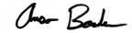 Brian Smock Anson Booker
Grand Adjutant Grand Commander

