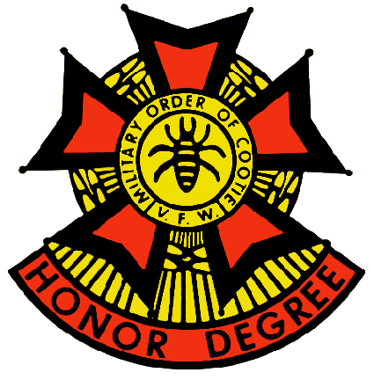
Grand of Texas

Military Order of the Cootie

Honor Degree of the Veterans of Foreign Wars

of the United States

2024-2025 Series General Orders No. 1 June 2024

- Having been duly elected and installed as Grand Commander, Grand Pup Tent of Texas, Military Order of the Cootie, at the 89th Grand Scratch in Copperas Cove, Texas on 1 JUN 2024, I Anson Booker, do hereby assume command under the provisions of Article IV, Sections 407, 408 and 409 of the bylaws of the Supreme Pup Tent for the 2024-2025 Cootie year.

- The term of office of all previously elected or appointed officers of the Grand Pup Tent of Texas for the 2023-2024 year has now expired and hereby declared null and void. All officers shall wear the proper tassels in accordance with Article VII, Section 701, paragraph “B” of the bylaws of the Supreme Pup Tent.

- All Officers elected or appointed to the Grand Pup Tent of Texas are entitled to and shall prefix the word “Grand” to their title in accordance with Article VII, Section 701, paragraph “B” unless elected or appointed to a higher office.

- Shavetails and Cooties with Official information to be published with the General Orders must submit same to Grand Adjutant, Brian Smock, 803 N. 3d Street, Copperas Cove, Texas 76522 or bsmock@hot.rr.com no later than the 21st of the preceding month.

- Please notify Grand Adjutant Brian Smock of all changes and/or corrections for the Grand Directory/roster and any discrepancies that may have been Published in the General Orders. Any questions about or corrections to the Grand Status Sheet should be addressed to the Grand Quartermaster Richard Kennedy richardcootie29@yahoo.com .

- The Grand Commander will notify Pup Tents of planned Official visits. The Grand Commander’s travel agenda won’t be routinely published in the General Orders. A tentative schedule will be included with the General Orders.

- All inspections reports shall be promptly submitted to the Grand Adjutant, Brian Smock, 803 N. 3rd St., Copperas Cove, TX 76522 (254) 220-6088 or email: bsmock@hot.rr.com. All inspections will be conducted by the Grand Inspector or the Grand Commander’s designated representative. A blank inspection report can be downloaded at LOTCs.org Please have one available for the inspector and fill out as much information as you can prior to the inspectors visit.

- All monies for Grand should be sent to the Grand Quartermaster. This includes PCT’s, Grand 50/50 monies and Horny Toad Programs. The Grand Stat Sheet will be generated by the Grand QM, but he needs input from all Grand Program Chairmen. No input, no relevant stats.

- Details of events scheduled by the VFW and Supreme organizations are published in their respective periodicals, and therefore won’t be duplicated here. Some key dates will be published as a reminder:

Department of Texas VFW
104th STATE CONVENTION
June 6-8, 2024 | Dallas, TX

105th Supreme Scratch
Marriot East Hotel
1903 Embassy Square Boulevard
Louisville, KY 31 JUL-04 AUG 2024

- All Pup Tents are required to register at least one delegate to the Supreme Scratch per section 531 of the Supreme By-Laws. The Delegate is not required to attend; you still must register one Delegate. Registration forms can be found on LOTCS.ORG

- Pup Tent 13 “DOOD IT”, has changed their Jun Scratch from Sunday 9 JUN 24 to Saturday 15 JUN 24, 10:30 AM because of a conflict with Department of Texas State Convention.

- All General Orders of the Grand Pup Tent are to be read and acted upon at all Pup Tent scratches. Following the reading, they are to be filed for future reference

Official: By Order of:
Brian Smock 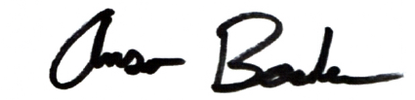
Brian Smock Anson Booker
Grand Adjutant Grand Commander

